Time Series Forecasting and Portfolio Optimization Using ARIMA Models on NSE Stocks

TSA 2026 Capstone Project Report

Submitted By
SAMPRIT BANERJEE

1. Introduction
Financial markets generate large volumes of sequential and time-dependent data, making time series analysis a highly effective approach for stock market forecasting and portfolio optimization. The primary objective of this project was to apply statistical forecasting techniques on historical NSE stock data in order to construct and evaluate a data-driven investment portfolio.
This capstone project focused on predicting stock price movements using ARIMA-based forecasting models and implementing the resulting investment strategy on the StockGro virtual trading platform. Historical stock data from 1 January 2021 to 31 December 2025 was collected using the Yahoo Finance API through the yfinance Python library.
The project workflow included:
- stock selection and diversification
- data preprocessing and stationarity testing
- ARIMA forecasting
- volatility and trend analysis
- portfolio construction
- real-time virtual trading on StockGro
- comparison of predicted vs actual market performance
The final objective was to evaluate whether time series forecasting techniques can effectively guide short-term portfolio allocation decisions under real market conditions.

2. Stock Selection Rationale
To ensure diversification and reduce portfolio concentration risk, stocks were selected from multiple sectors of the Indian economy. Sector diversification improves portfolio stability because different sectors react differently to market conditions.
The selected stocks were:
Stock | Sector
HDFCBANK.NS | Banking
TCS.NS | Information Technology
SUNPHARMA.NS | Pharma
HINDUNILVR.NS | FMCG
MARUTI.NS | Automobile
RELIANCE.NS | Energy

Selection Methodology
The stock universe was selected using the following approaches:

1. Sector Diversification- Stocks were chosen from distinct industries to reduce exposure to sector-specific risk.

2. Rolling Volatility Analysis- Rolling standard deviation over a 30-day window was computed to analyze volatility behavior across stocks.

3. Trend Analysis Using STL Decomposition- Seasonal and trend decomposition was used to identify long-term directional movement and cyclical behavior.
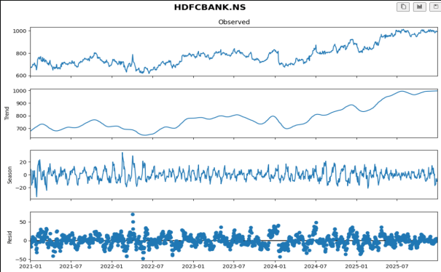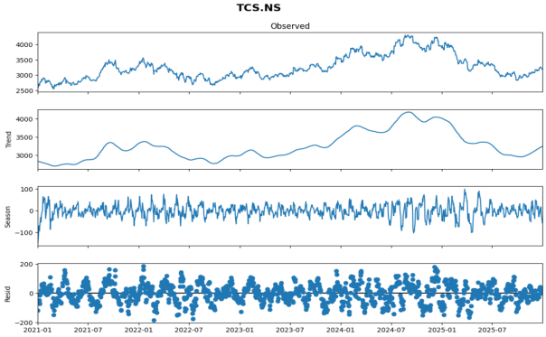

4. Market Leadership- The selected companies are among the largest and most actively traded stocks in their respective sectors, ensuring strong liquidity and reliable historical data.

3. Data Collection and Preprocessing

Dataset Specification
Parameter | Value
Source | Yahoo Finance
Library Used | yfinance
Time Period | 2021-01-01 to 2025-12-31
Frequency | Daily
Split Strategy | Train/Test
The training data consisted of all observations before July 2025, while the last six months of data were used for testing and validation.

Missing Value Handling
Missing values were handled using forward fill and backward fill techniques.
stock_data[stock] = stock_data[stock].ffill().bfill()

Stationarity Testing
The Augmented Dickey-Fuller (ADF) test was used to determine whether the stock price series were stationary.
- Null Hypothesis: series is non-stationary
- Alternative Hypothesis: series is stationary
If the p-value exceeded 0.05, differencing was applied.

Train-Test Split
Dataset | Period
Training Set | Before July 2025
Testing Set | July 2025 – December 2025

4. Forecasting Methodology

ARIMA Model
The AutoRegressive Integrated Moving Average (ARIMA) model was used for forecasting future stock prices.
ARIMA combines:
- AutoRegression (AR)
- Integrated differencing (I)
- Moving Average (MA)
The p, d, q parameters were automatically optimized using the auto_arima function.

Forecasting Procedure
For each stock:
- Historical training data was used to fit the ARIMA model.
- Predictions were generated for the testing period.
- Future forecasts were generated for the next 5 trading days.
- Model performance metrics were computed.

Evaluation Metrics

Root Mean Squared Error (RMSE)- Measures forecasting error magnitude.

Mean Absolute Percentage Error (MAPE)-Measures percentage forecasting accuracy.

Directional Accuracy-Measures whether the model correctly predicted stock movement direction.

5. Volatility and Trend Analysis

Log Return Computation
Log returns were computed using: r(t) = ln(P(t) / P(t-1))
where: · P(t) is current closing price
· P(t-1) is previous closing price

Rolling Volatility
A 30-day rolling standard deviation of log returns was used to estimate short-term market volatility.
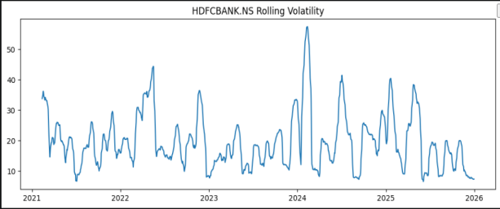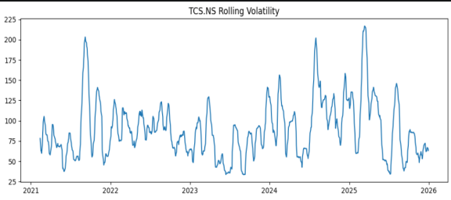
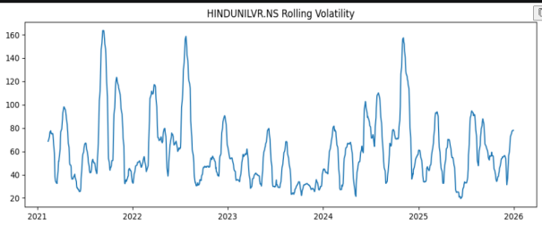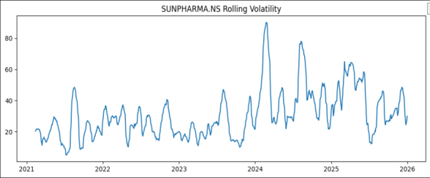
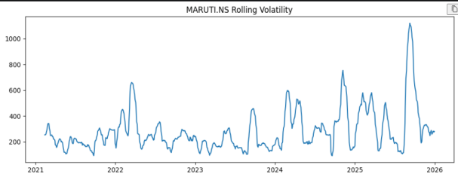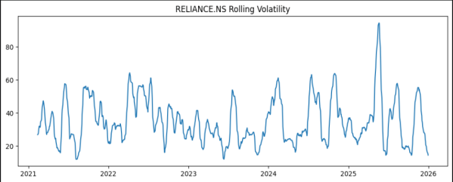

STL Decomposition
Seasonal Trend decomposition using Loess (STL) was applied to separate:
- trend component
- seasonal component
- residual/noise component
The decomposition plots revealed that most selected stocks demonstrated long-term upward trends with moderate seasonal fluctuations.

6. Correlation and Diversification Analysis
To minimize portfolio-level risk, correlation analysis was performed across all selected stocks.
A correlation heatmap was generated using percentage returns.
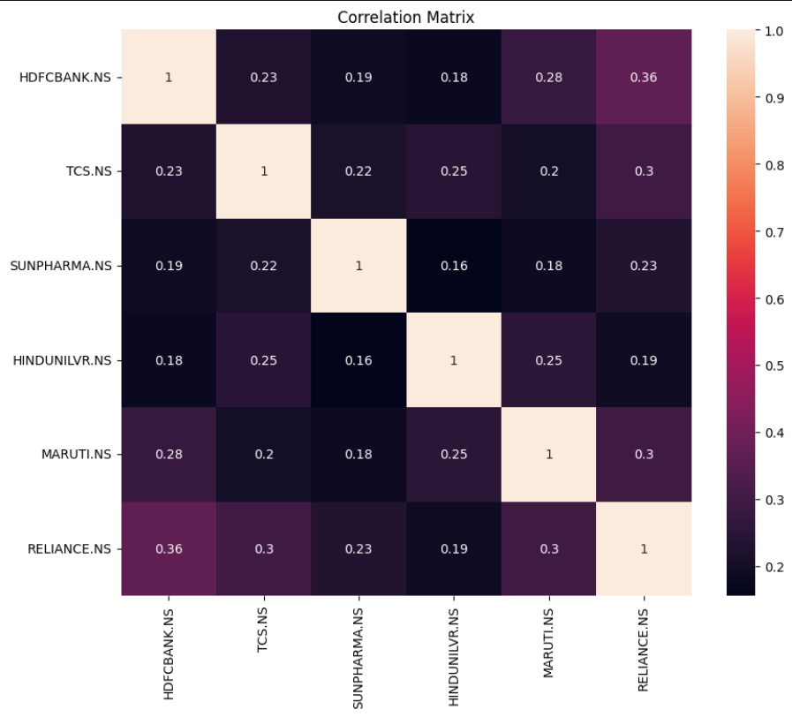
The analysis showed that:
- sector diversification reduced correlation concentration
- banking and FMCG stocks behaved more defensively
- IT and automobile sectors displayed higher volatility
This diversification strategy helped reduce overall portfolio risk during the live trading window.

7. Portfolio Construction
Portfolio allocation was based on:
- volatility-aware weighting
- forecast-guided allocation
- diversification strategy

Volatility-Aware Weighting
Stocks with lower predicted volatility received larger allocations.
The weighting formula used was:
w(i) = (1 / sigma(i)) / SUM(1 / sigma(j))
where sigma(i) represents predicted volatility.

Final Portfolio Allocation
Stock | Sector | Weight (%) | Allocated Amount (₹)
HDFCBANK.NS | Banking | 17.06 | 170569.02
TCS.NS | IT | 16.94 | 169364.68
SUNPHARMA.NS | Pharma | 17.07 | 170747.89
HINDUNILVR.NS | FMCG | 17.65 | 176461.35
MARUTI.NS | Auto | 15.56 | 155577.80
RELIANCE.NS | Energy | 15.73 | 157279.27
Total capital deployed: ₹10,00,000

8. Model Evaluation
The ARIMA model was evaluated using historical testing data.
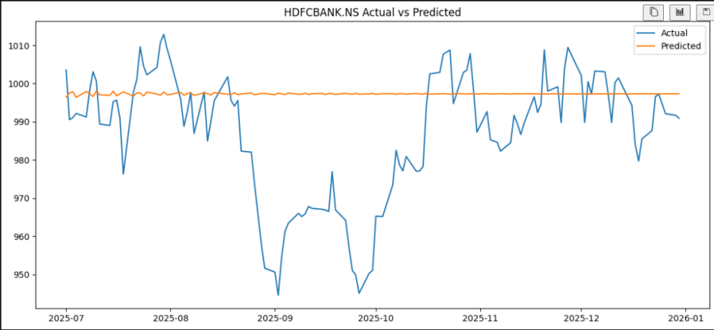
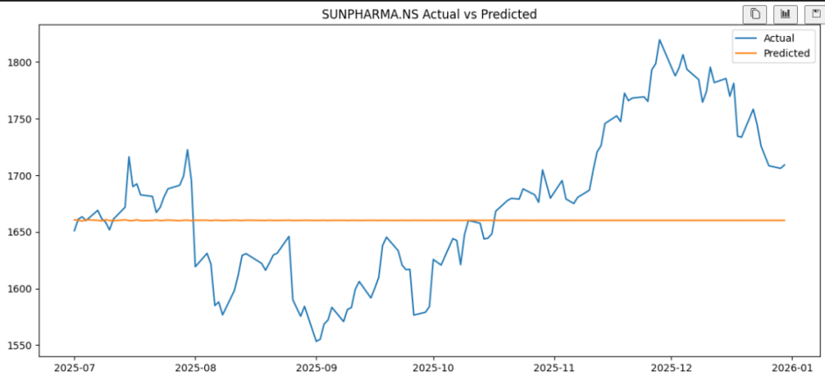
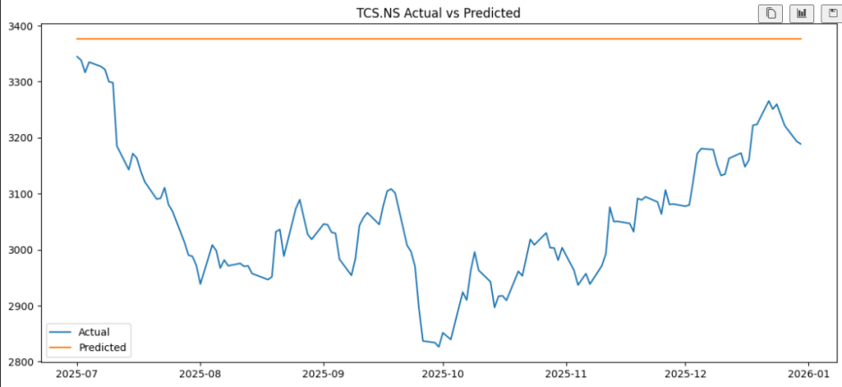
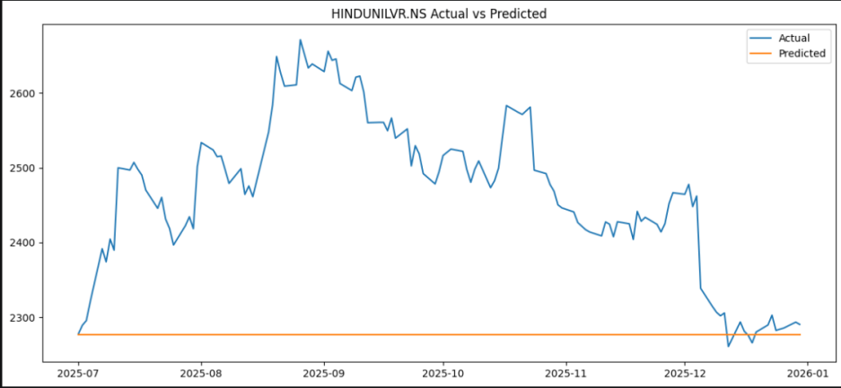
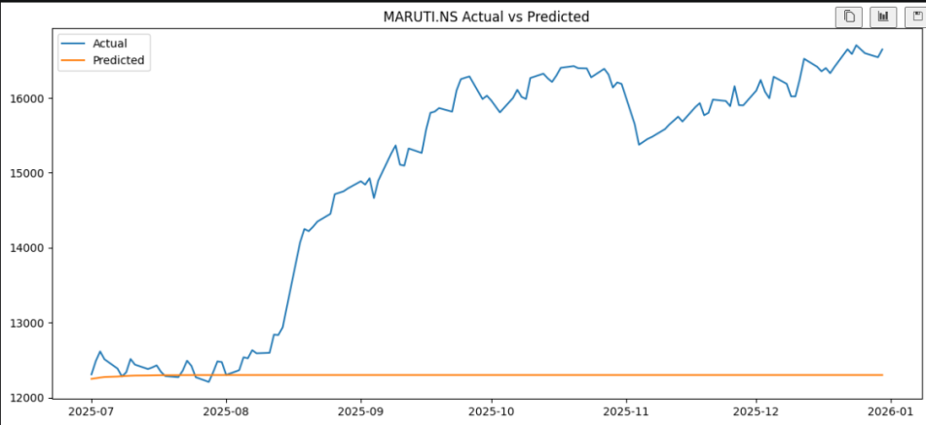
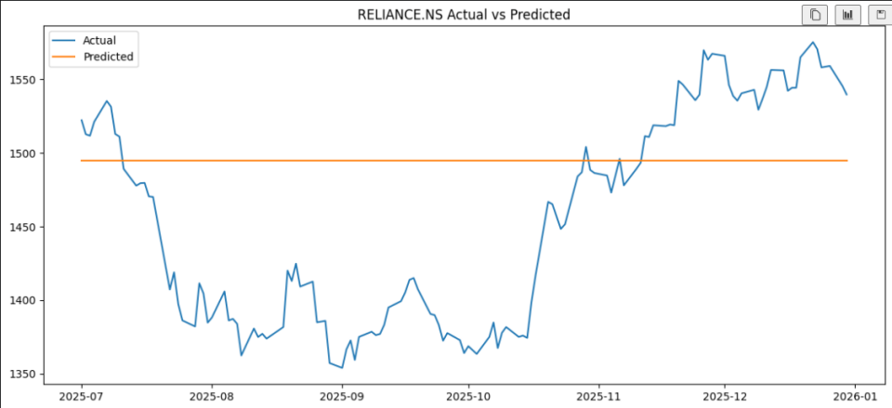

Observations

Strengths
- effective for short-term forecasting
- interpretable statistical structure
- efficient on structured financial data
- stable forecasting performance on low-volatility stocks

Limitations
- struggled with sudden market fluctuations
- limited ability to capture nonlinear behavior
- sensitive to high volatility periods

Overall Assessment
The ARIMA model produced reasonable short-term forecasts and successfully generated a balanced portfolio allocation strategy.

9. StockGro Execution Summary
The generated portfolio was implemented on the StockGro virtual trading platform.

Trading Window
Wed 13 May → Thu 14 May

Execution Details
All trades were executed according to the portfolio allocation generated by the forecasting pipeline.
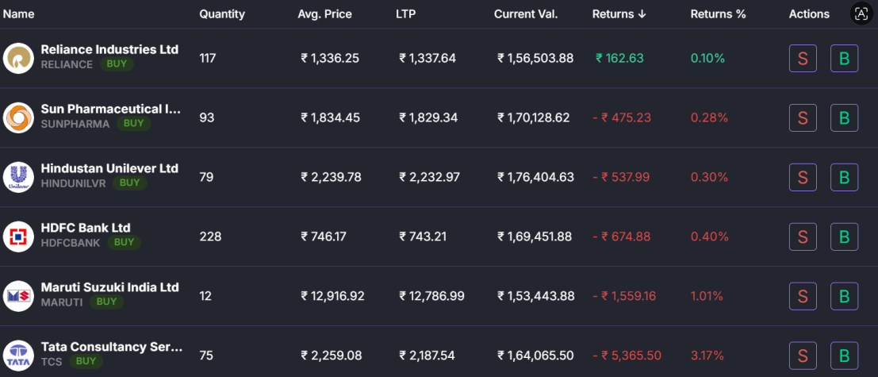

Initial Portfolio Snapshot
Metric | Value
Initial Capital | ₹10,00,000
Invested Value | ₹9,98,448.52
Portfolio Type | Diversified Multi-Sector
The portfolio consisted of:
- HDFC Bank
- TCS
- Sun Pharma
- Hindustan Unilever
- Maruti Suzuki
- Reliance Industries
Screenshots of holdings, allocation, and portfolio returns were recorded as proof of execution.

10. Predicted vs Actual Market Performance
The portfolio was monitored over the selected two-day trading window.

Actual Market Observations

Best Performing Stock - HDFCBANK.NS

Worst Performing Stock - TCS.NS

Portfolio Outcome
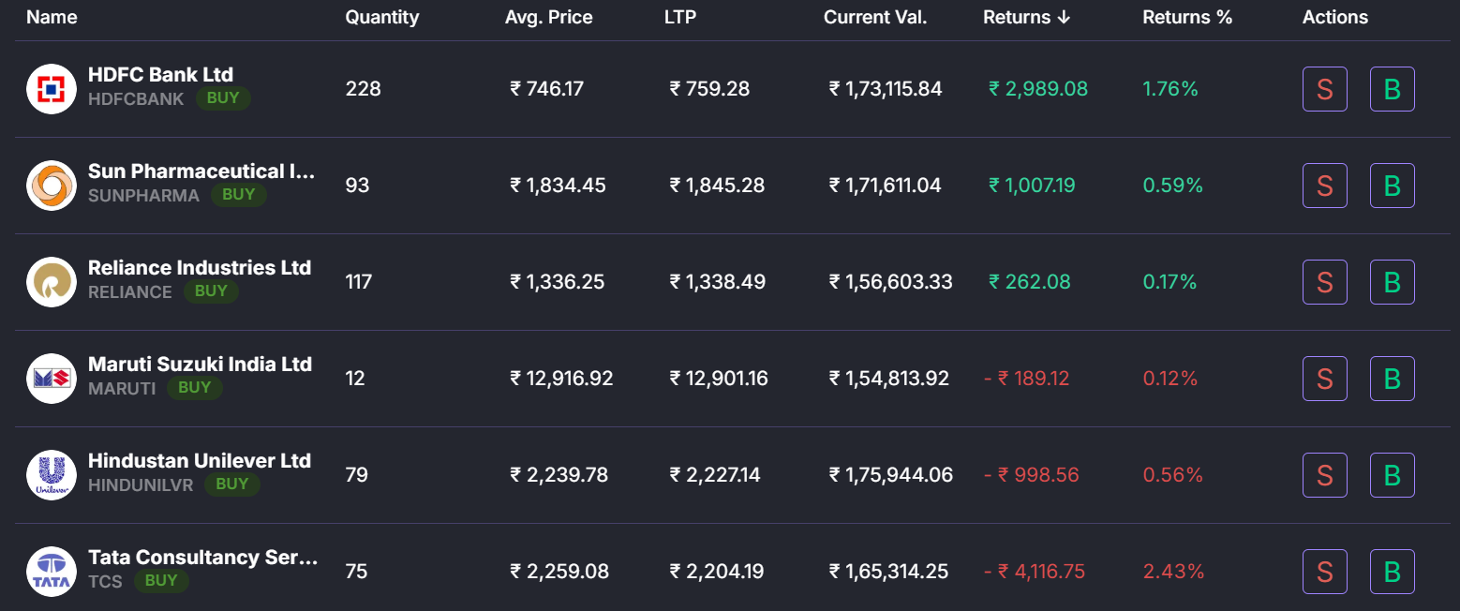

Initial Capital: ₹10,00,000
Final Portfolio Value: ₹9,96,403.99
Net Return: -₹2,044.53 (-0.20%)

Interpretation
Although TCS and MARUTI generated significant negative returns during the trading window, positive contributions from HDFCBANK and RELIANCE helped reduce the portfolio drawdown.
The portfolio remained relatively stable despite volatile market conditions.

Key Insight
The diversification and volatility-aware allocation strategy successfully limited downside risk.

11. Reflection and Conclusion
This project demonstrated how statistical forecasting techniques can be integrated with portfolio construction and real-time market execution.
The ARIMA model provided useful short-term forecasting capability, particularly for stable stocks with stronger historical structure. However, sudden market fluctuations and external factors reduced prediction accuracy for highly volatile stocks such as TCS and MARUTI.
Several important conclusions were observed:
- diversification significantly improved portfolio stability
- volatility-aware allocation reduced major losses
- forecasting models alone are insufficient without risk management
- real market behavior contains randomness beyond historical trends
Despite a small overall portfolio decline of 0.20%, the portfolio remained relatively resilient under live market conditions.

Future Improvements
The following improvements could further enhance forecasting accuracy:
- integrating LSTM or transformer-based models
- incorporating technical indicators
- including macroeconomic variables and news sentiment
- using ensemble forecasting techniques
- dynamic portfolio rebalancing
Overall, the project successfully achieved its objective of applying time series analysis techniques to data-driven portfolio construction and live virtual trading.

12. Technologies and Libraries Used
Tool/Library | Purpose
Python | Core Programming
yfinance | Data Collection
pandas | Data Processing
numpy | Numerical Computation
matplotlib | Visualization
seaborn | Heatmaps and Graphs
statsmodels | ARIMA and Statistical Tests
pmdarima | Automatic ARIMA Tuning
Streamlit | Dashboard Development
StockGro | Virtual Trading Platform

13. Appendix

Included Deliverables
- Jupyter Notebook
- Portfolio Allocation Tables
- Forecast Graphs
- Correlation Heatmap
- STL Decomposition Plots
- StockGro Screenshots
- Streamlit Dashboard

GitHub Repository:
https://github.com/yourusername/tsa-2026-capstone
Live Dashboard:
https://yourapp.streamlit.app

End of Report

